**Extracting twitter data through rapidminer:**

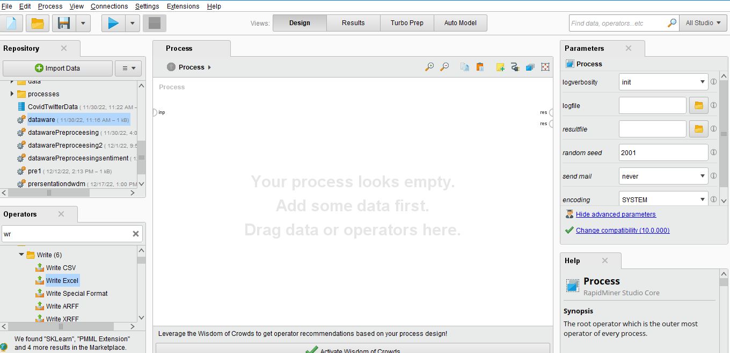

**In OPERATOR panel write twitter**

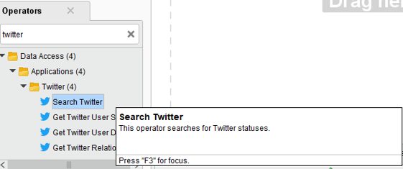

**Then drag and drop SEARCH TWITTER**

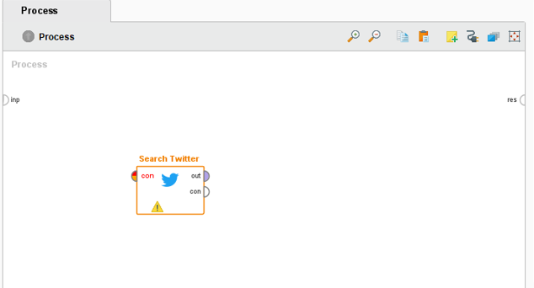

**CLICK ON TWITTER “ICON” AND CLICK ON CONNECTIONS**

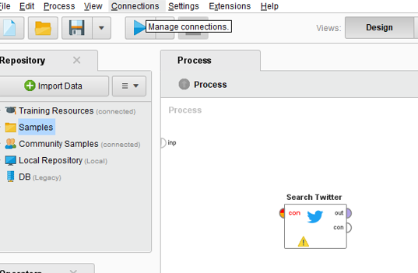

And in connections press on “CREATE CONNECTIONS”

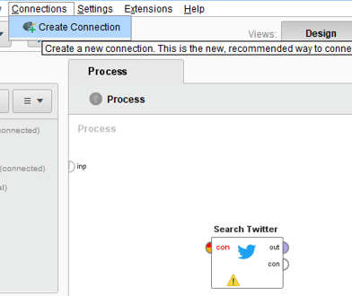

This screen will appear

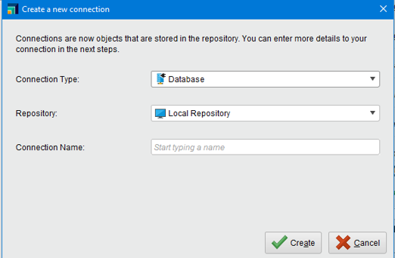

In connection type select the “TWITTER”

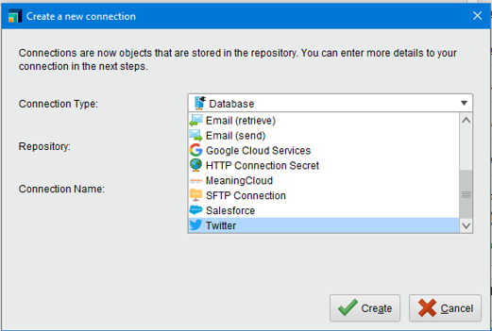

Now name the Connection Name “TwitterConn” or any name you want for connection name

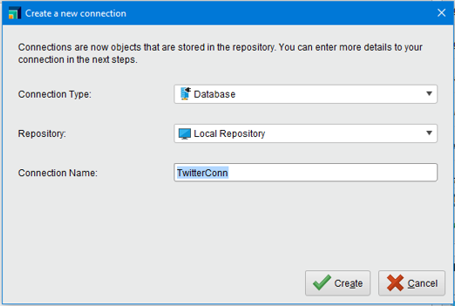

Then press on “Create”

And a new screen will appear

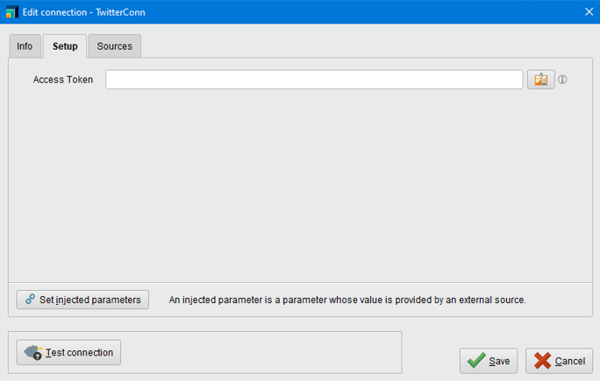

Click on this button icon

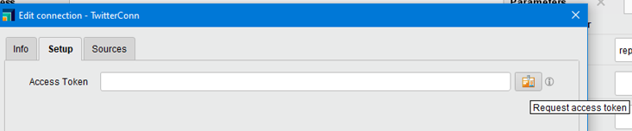

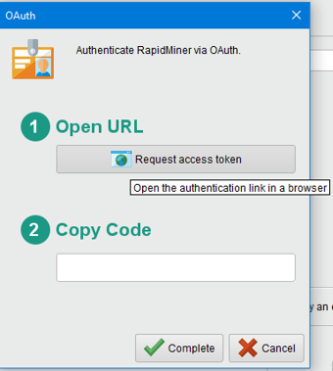

Now click on button “REQUEST ACCESS TOKEN”

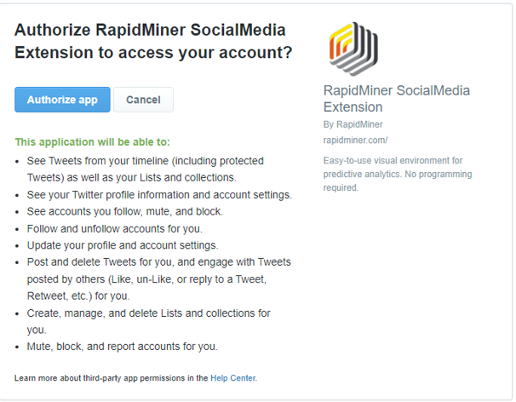 If you are not logined into twitter the login page will show you

After login ,this page will show you

Now click on “AUTHORIZED APP”

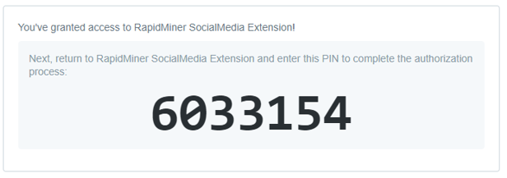

COPY this PIN n Paste inside the COPY CODE

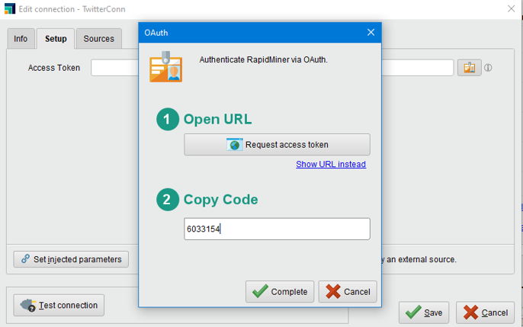

Click on the COMPLTETE

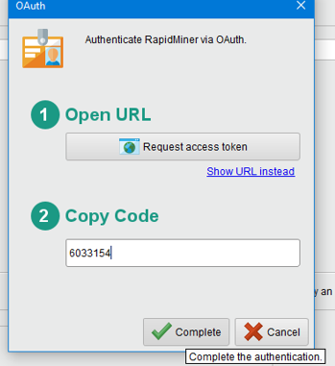

It Authenticates and access token is provided

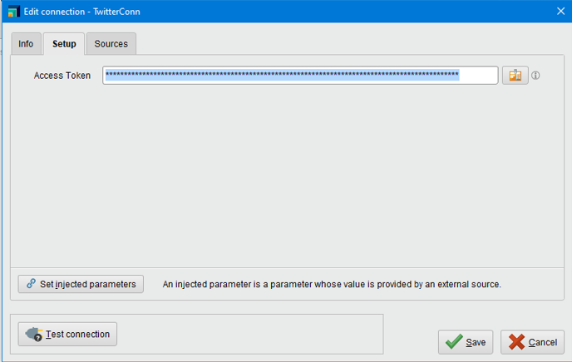

Now click on test connection:

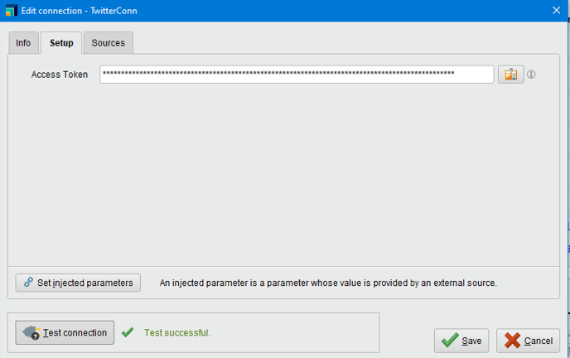

Now save it

Now again click on search twitter

In side your right window click on connection entry

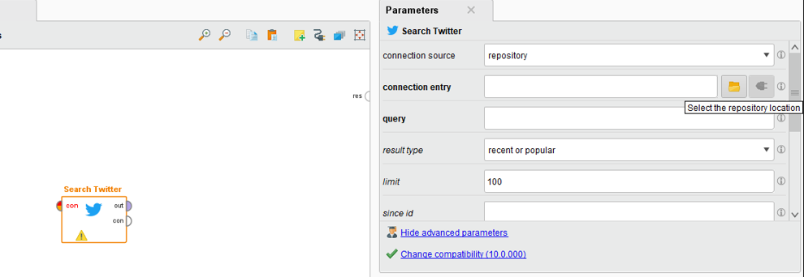

This window will appear

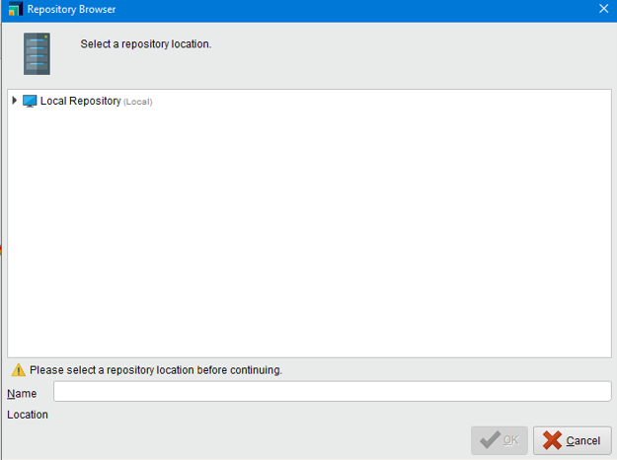

Select location from the repository n Click on OK

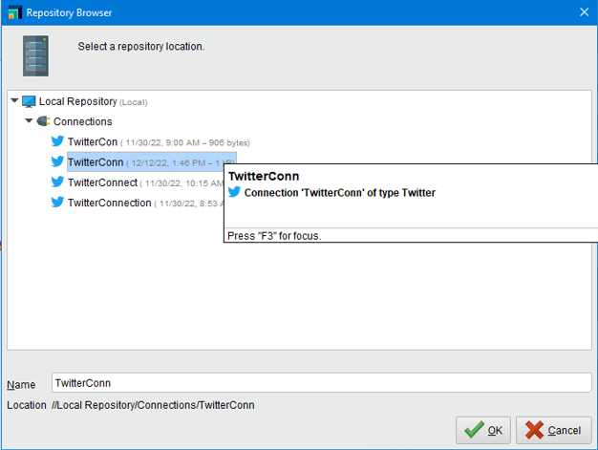

Query “COVID” n limit 5000:

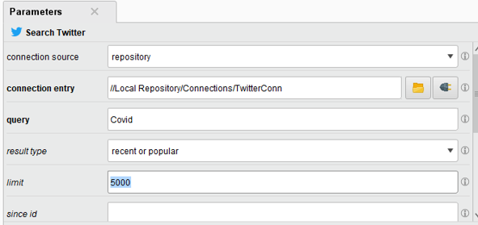

Recent and popular n Language is “en”

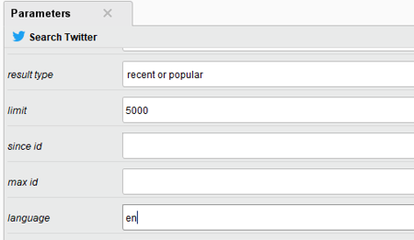

Now in operators select “EXCEL”

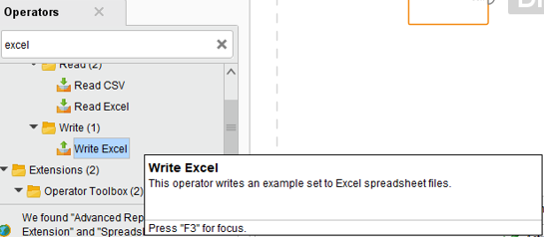

Drag and drop it

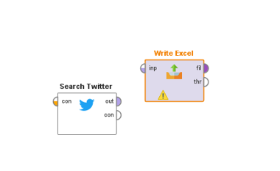

Join as search twitter output as an input of the excel

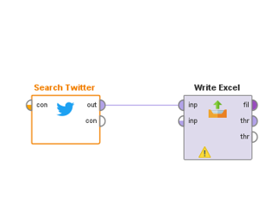

Click on the excel and give it a path

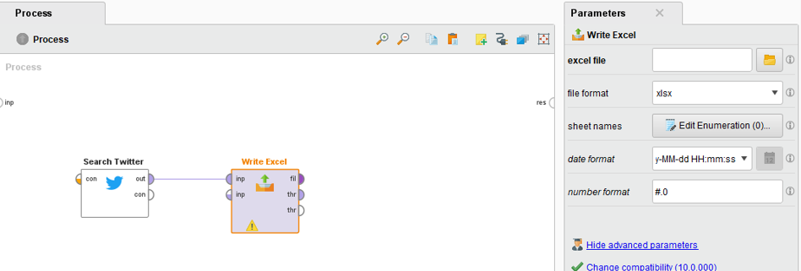

Click where you want to save your excel file ,we have saved it in the destop

Name the file, Open it

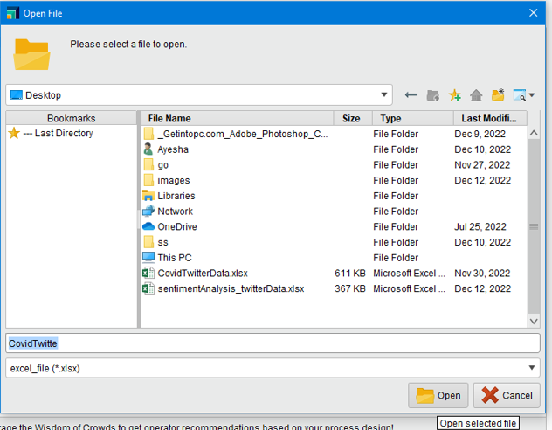

Format of file

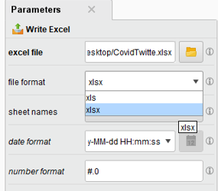

Now click on the run button

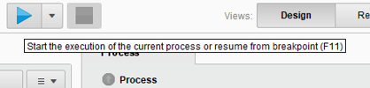

It storing all the 5000 tweets in the excel file

It save an excel file in the destop



Now delete the “write excel” by simply selecting and press delete button

Now show me directly output of the data

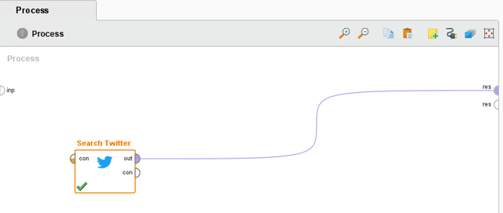

And again execute

You will see all the tweets came in the result

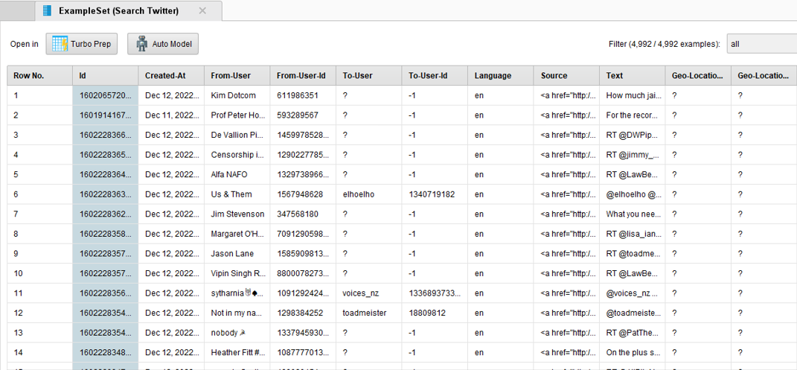

**NOW PREPROCESSING AND TEXT MINING ON TWITTER DATA**

Save the previous file and open a new process where preprocessing algos will implement on the data

In operator search “READ EXCEL” AND DRAG AND DROP

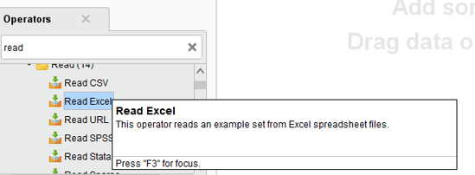

Choose file from the right panel

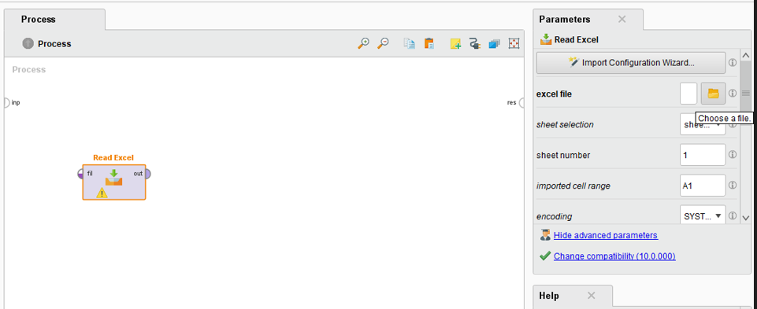

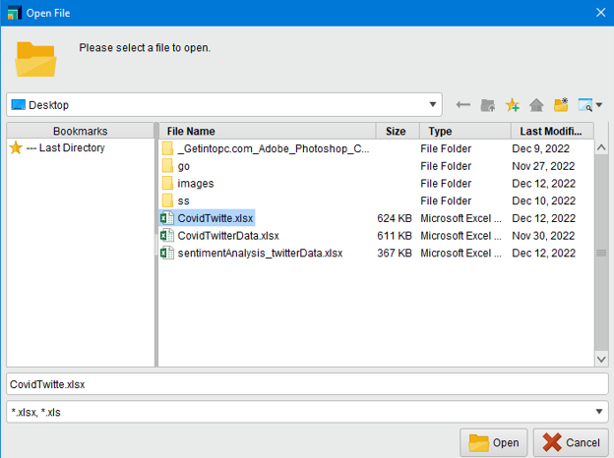

Open and make connection

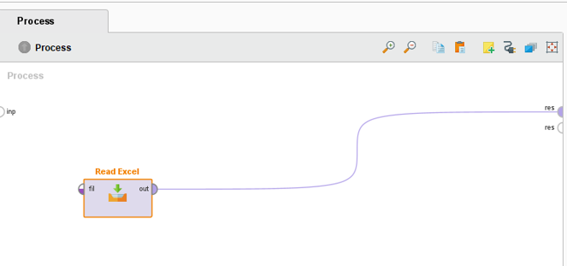

Now run

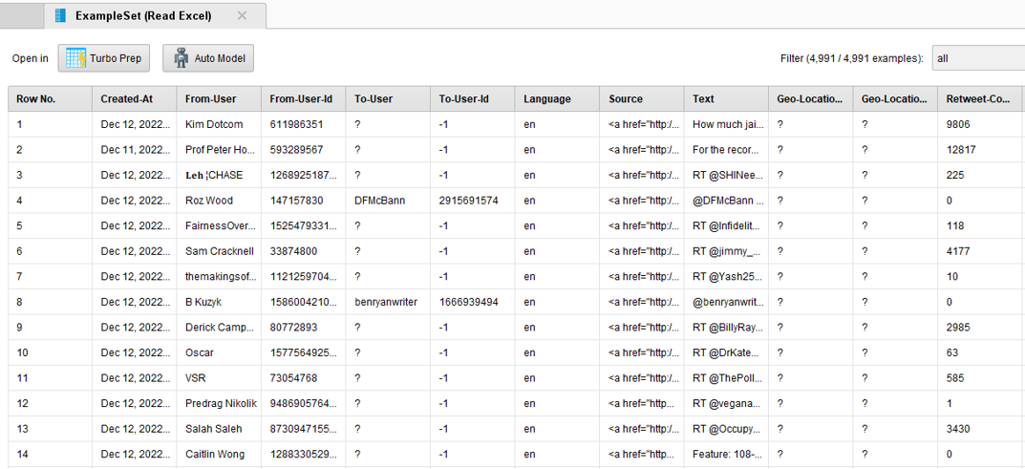

In text attribute where tweets are there we firstly remove the http links and then tags@

REMOVE THIS LINK

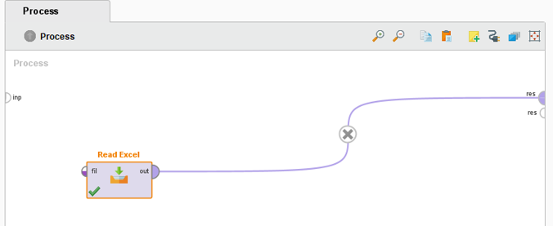

Now search and drag and drop the SELECT ATTRIBUTE

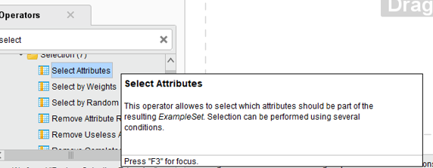

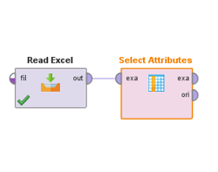

Select subset right panel n select attribute

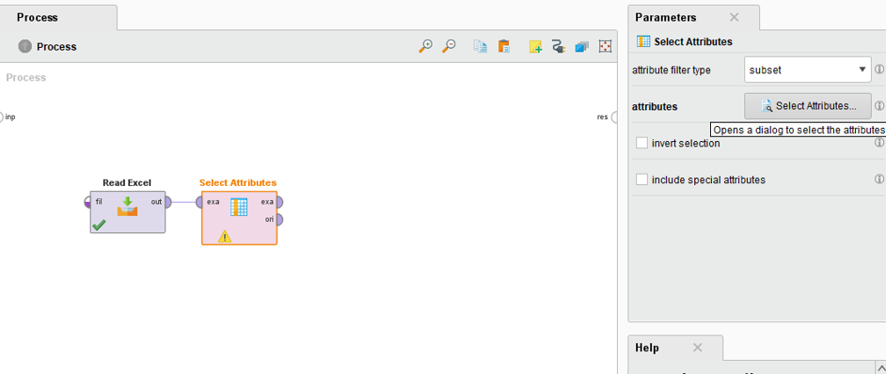

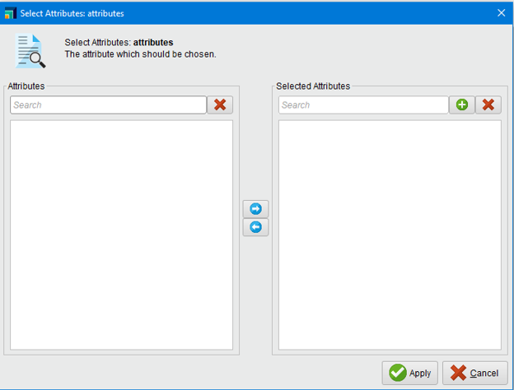

This error will show so you need to goback to read excel to made a configuration

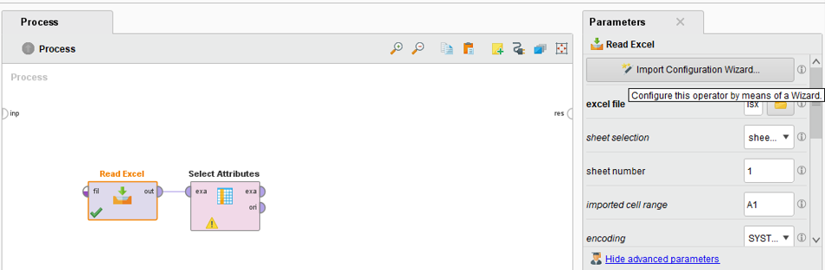

Click on IMPORT CONFIGURATION

AGAIN SELECT THE TWITTER DATA

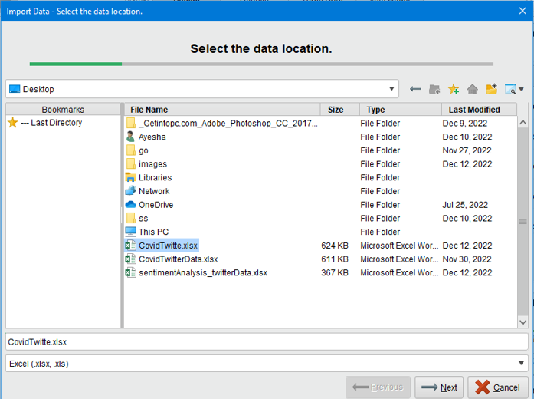

NOW CLICK ON NEXT

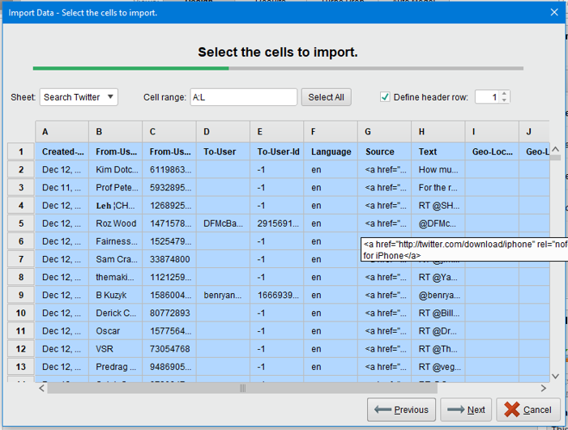

now next again and click finish

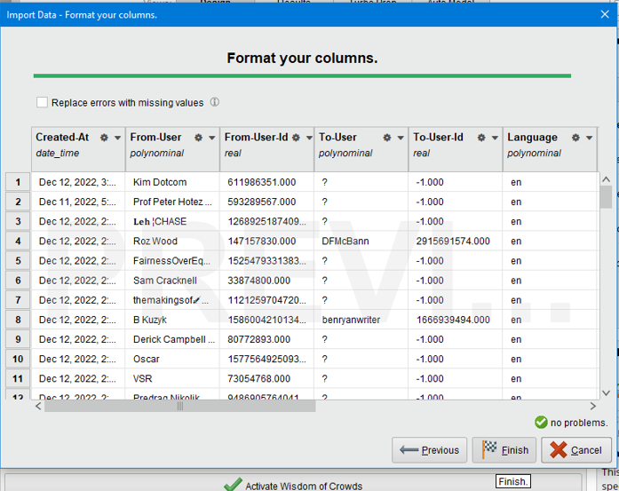

Go again and click the select attribute

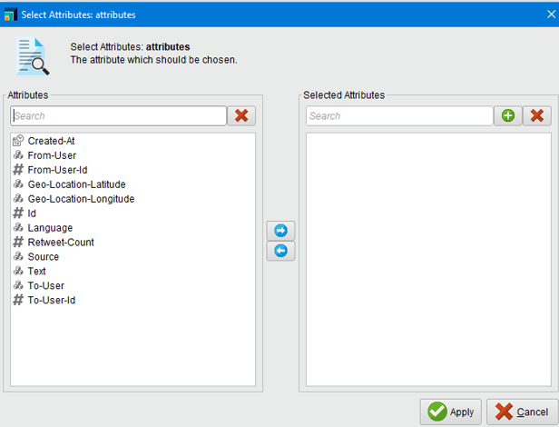

Click on attributes you want

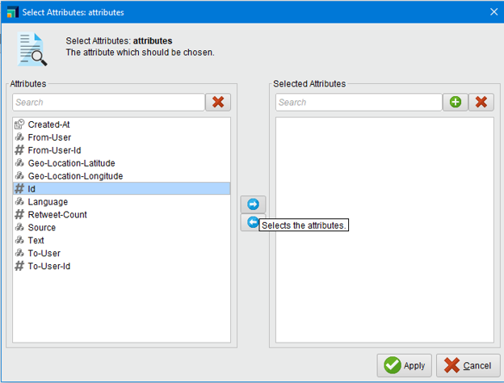

These attributes we have selected

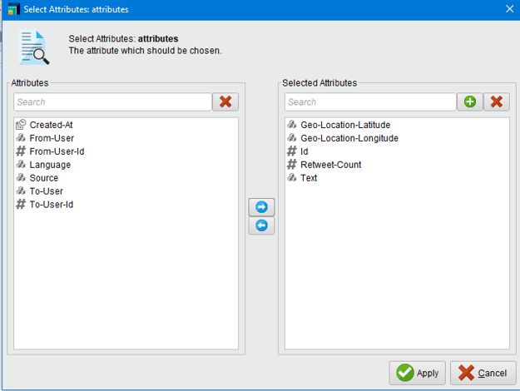

Click on apply

Make again connection and execute

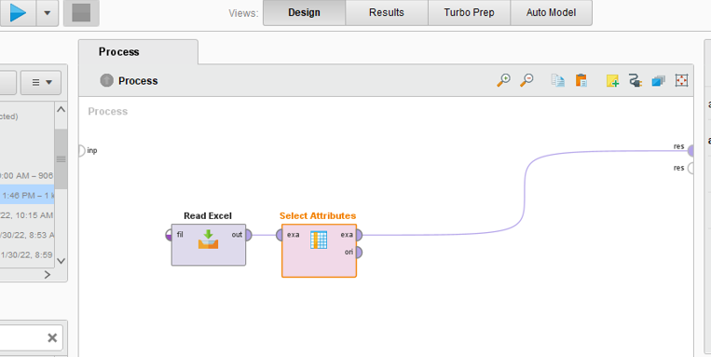

Now only these attributes showed

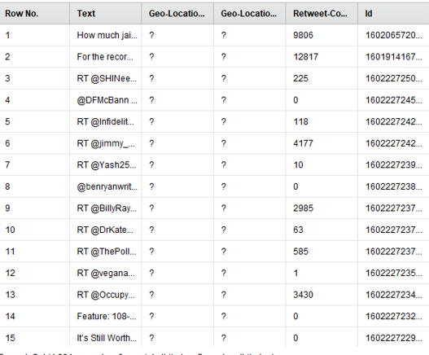

In operator click and drag drop nominal to text

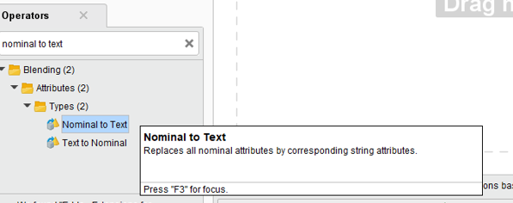

And make it connections

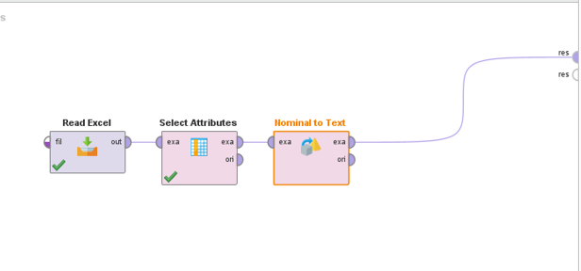

Execute

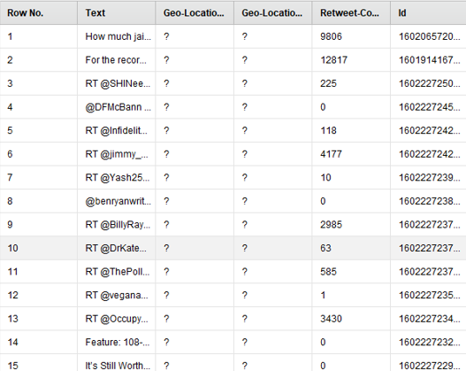

After applying nominal to the text

Again remove the connection in design

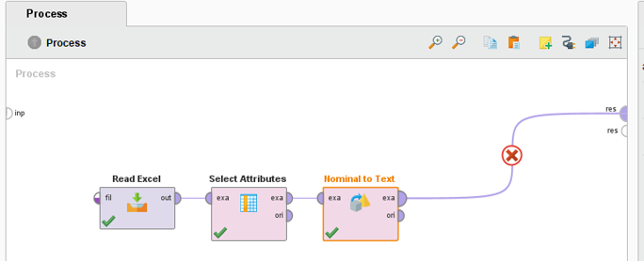

On the top go to extension and select marketplace

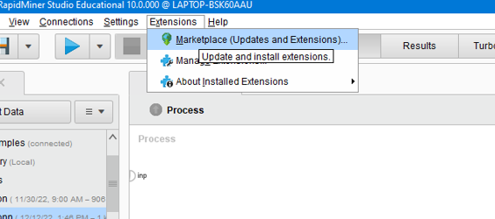

Search operator

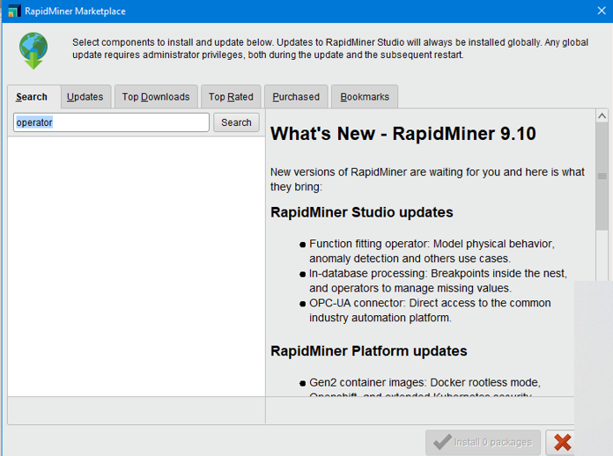

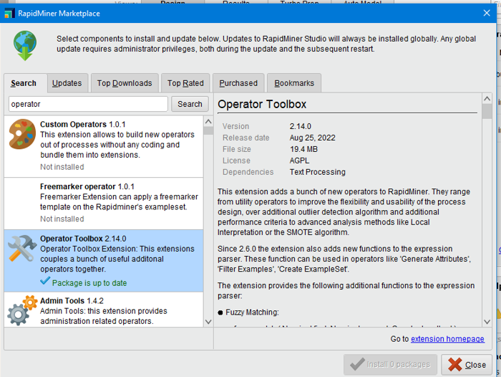

text preprocessing

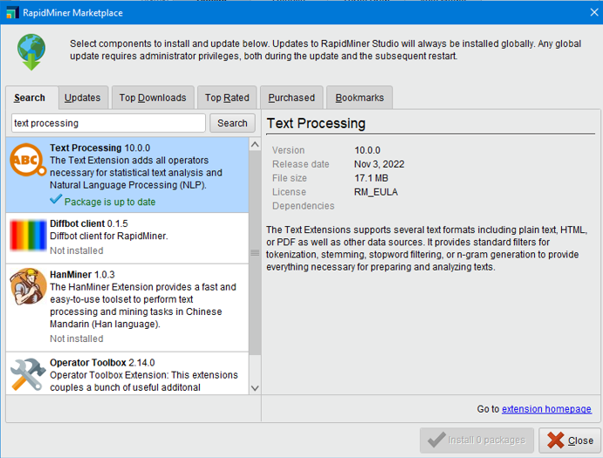

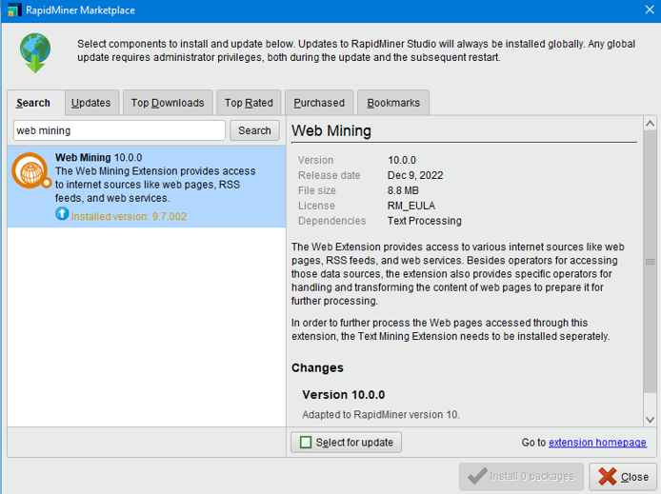

Now click on SELECT ATTRIBUTE

On left panel select the “single and attribute select “text n single

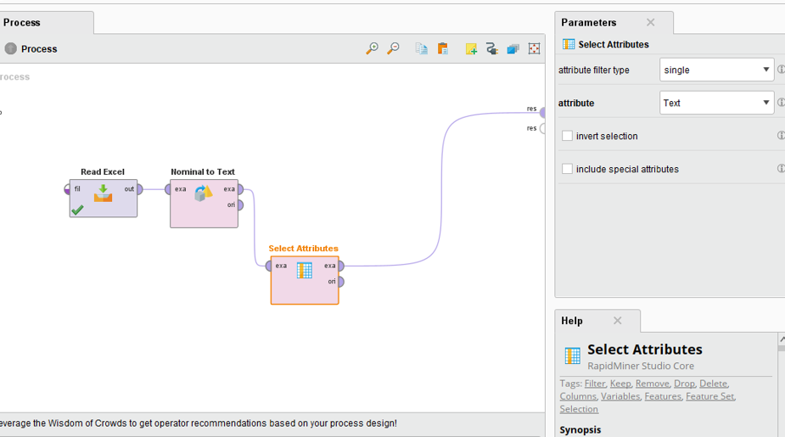

execute

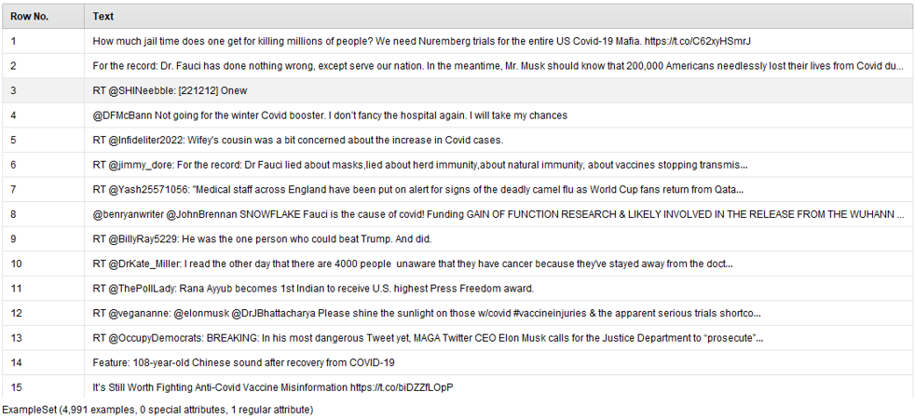

**Now pre-processing**

Click replace and drop from operator

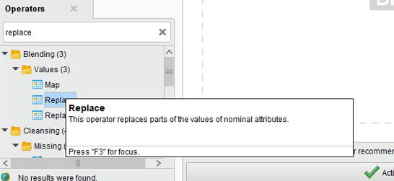

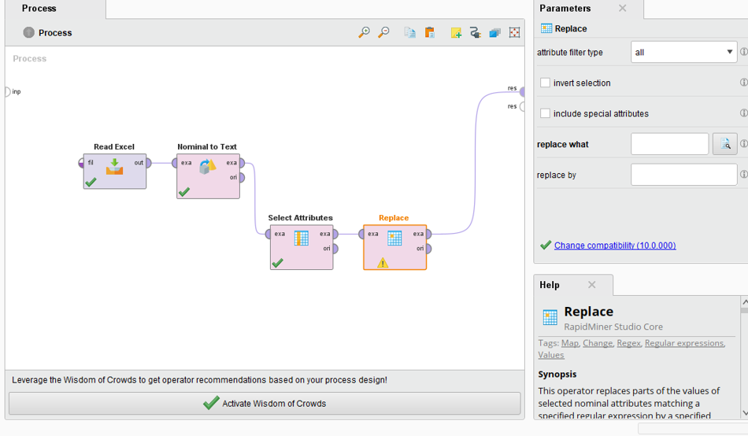

Link in the bio replace what link: **https?://[-a-zA-Z0-9+&@#/%?=_|!:,.;]*[-a-zA-Z0-9+&@#/%=_|]**

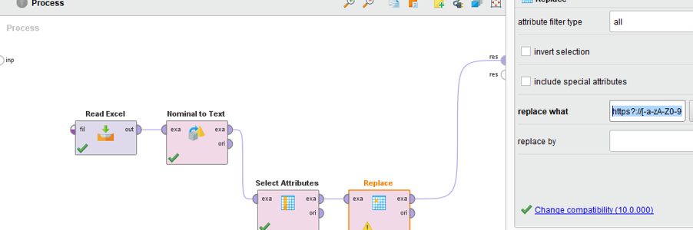

And click on the RUN button and you will see it removed all the **http linked**

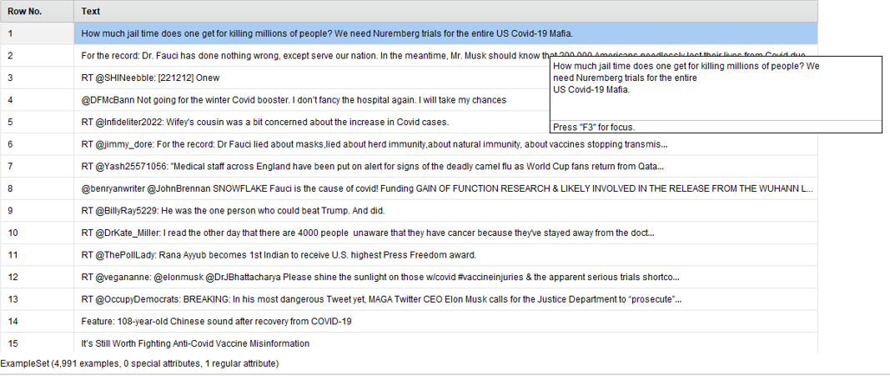

Now go back operator and click

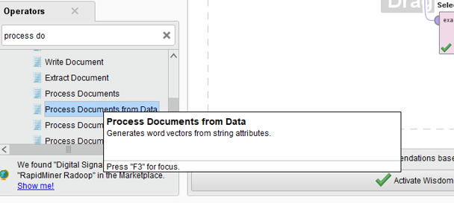

drop it and make connection

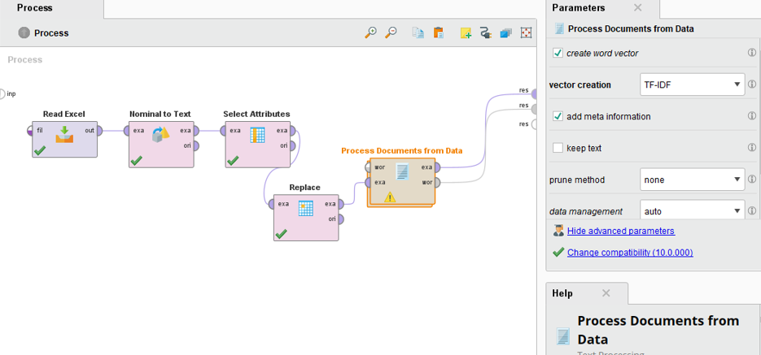

double click on the process document on data and this page will open

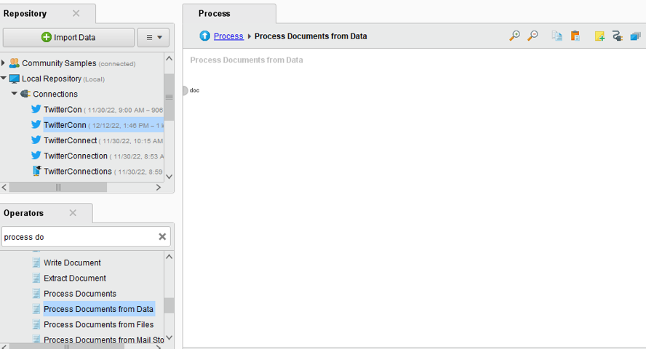

And now tokenize the word by drag and drop

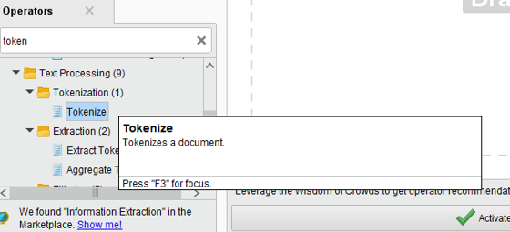

And now make connection

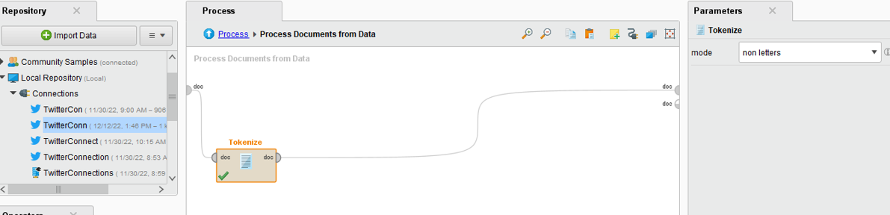

Run it

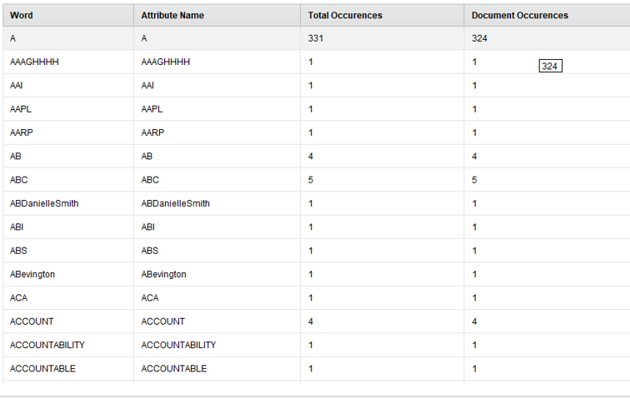

Now click on total occurrence to calculate which term is occur more in particular document

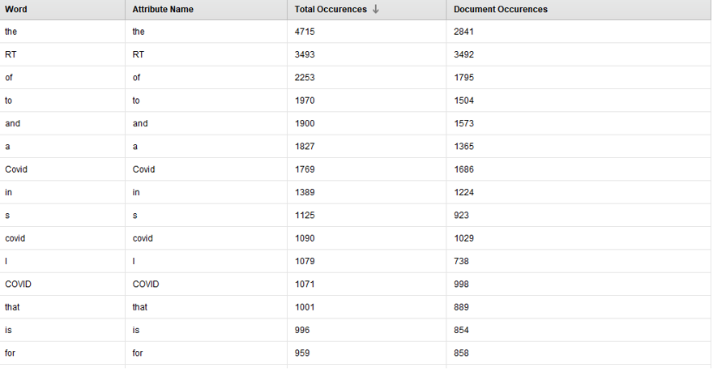

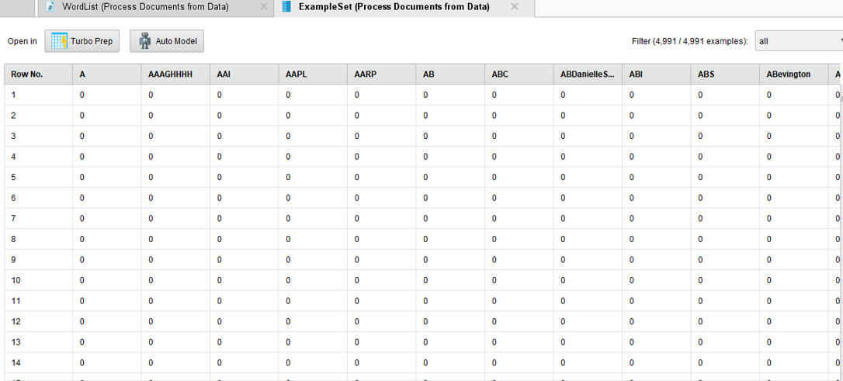

Select the transform cases from operator and drop it. Select the lower or upper case which you want your document to convert

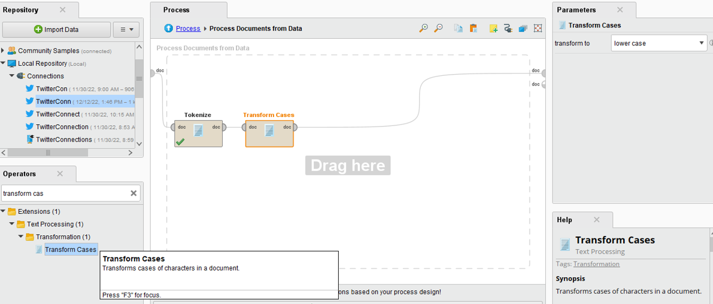

And then remove the stop words and select the filter stop words (ENGLISH)

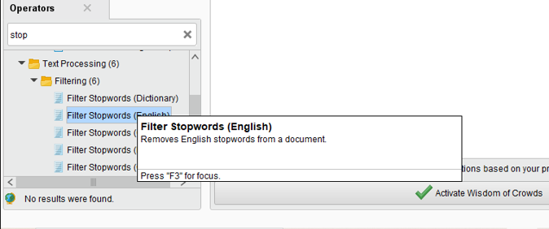

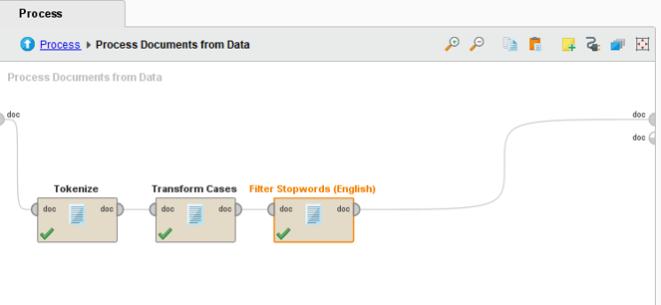

Output:

Press on total occurrence to see result

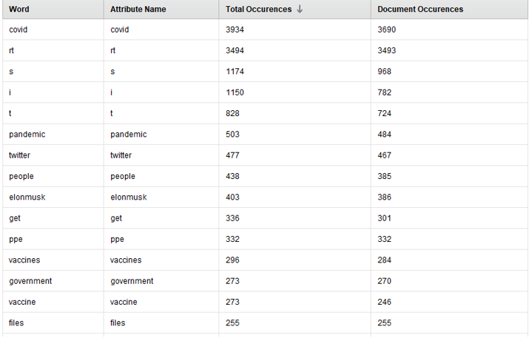

All words are in lower case and it removes the stop words.

Now again click on the PROCESS to view the other process

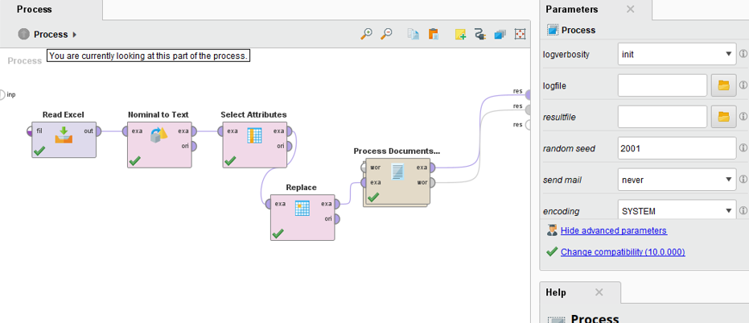

Now add “replace” from operator

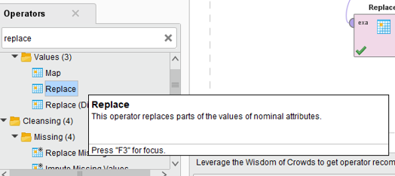

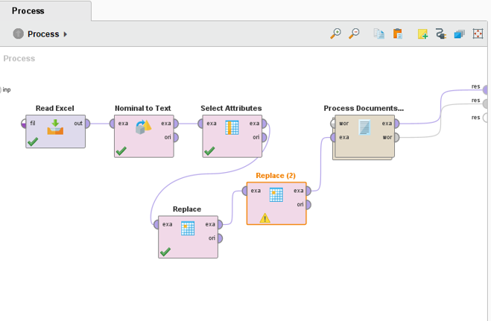

Remove by pasting link **“RT\s*@[^:]*:\s*[A-Za-z ]+”**

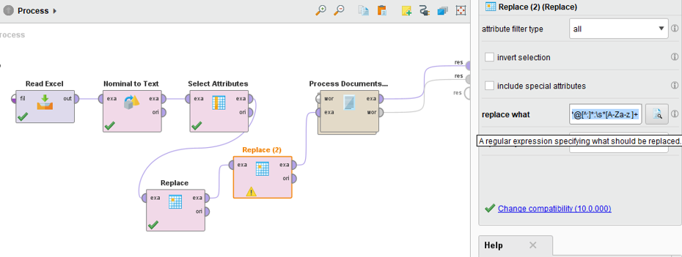

Now again run the program

Removing Retweet - RT@ from Tweets

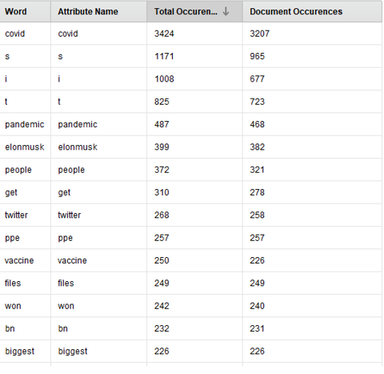

Now open “process document” from data

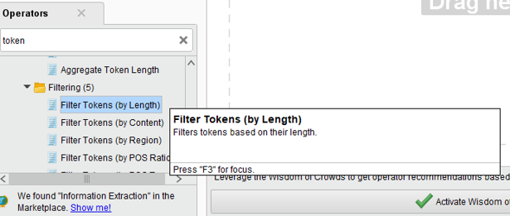

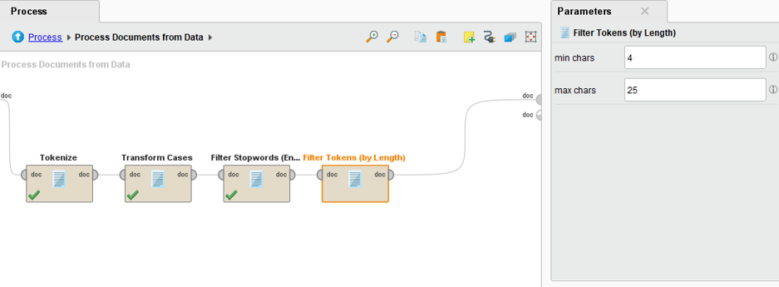

And now execute

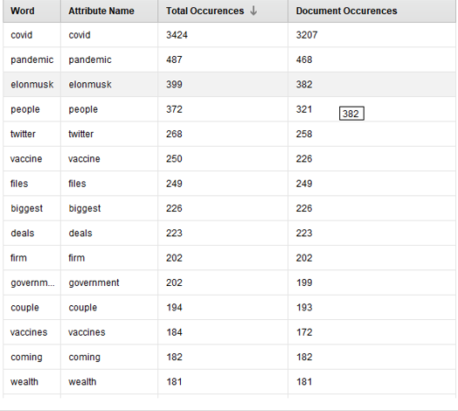

Word Cloud in Text Analysis

Select “**list to data”** from OPERATOR

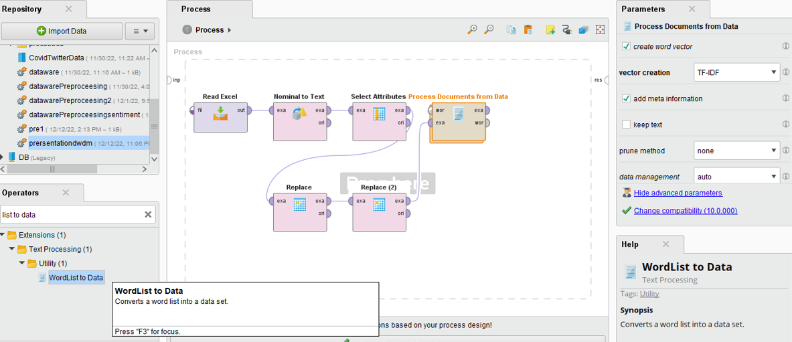

Now drag n drop

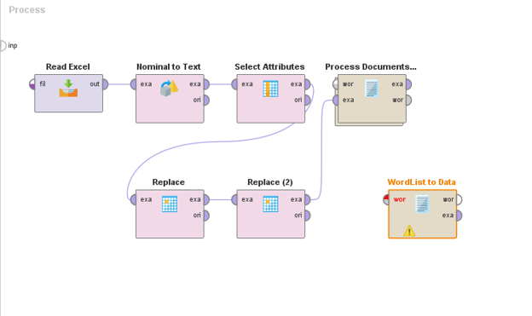

Connect process document to word to list:

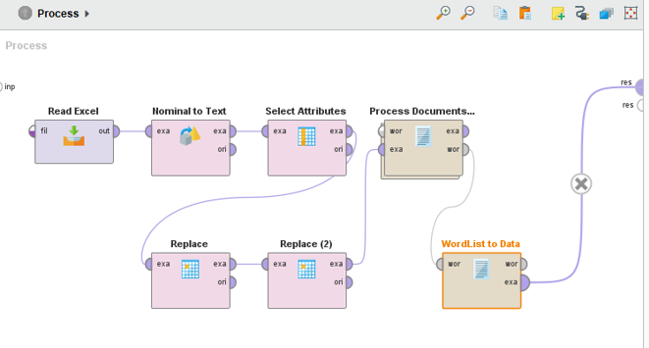

Then EXECUTE

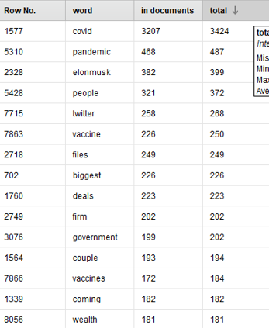

**Drag and drop SORT OPERATOR**

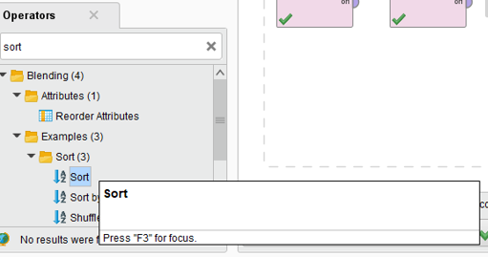

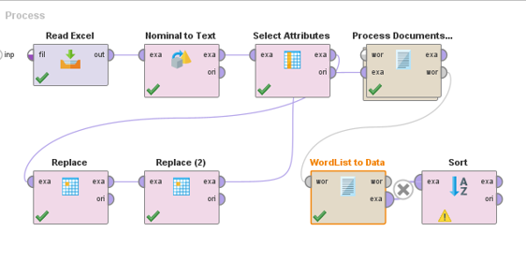

**Click on sortby**

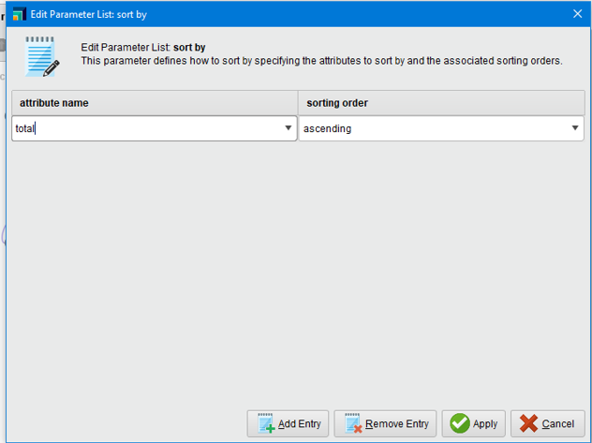

Search FILTER EXAMPLE RANGE

**Drag n drop**

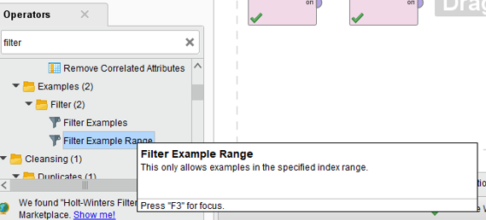

**And connect it with sort**

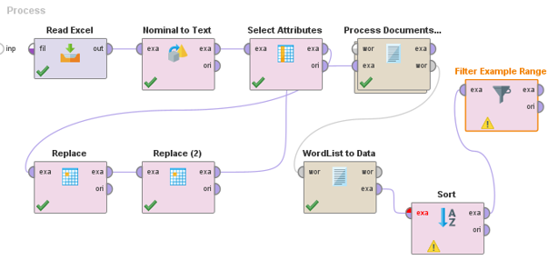

**Top 20 words**

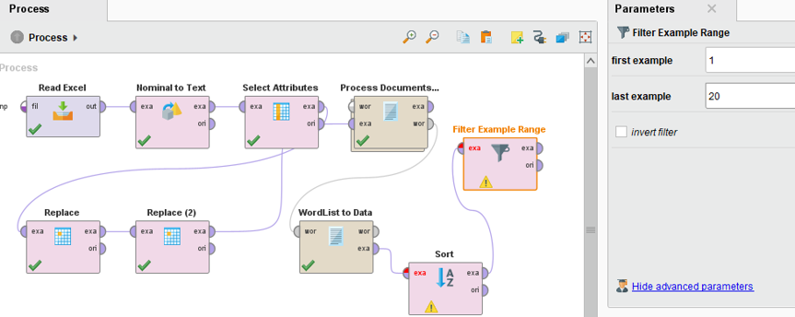

**Shows top 20 :**

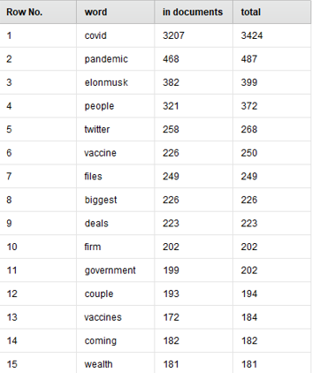

**Go in visualization:**

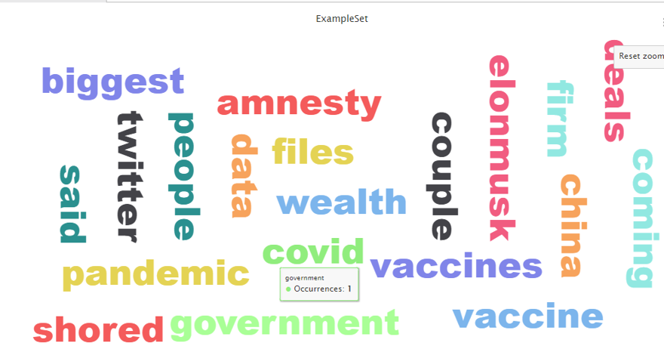

**Perform stemming**

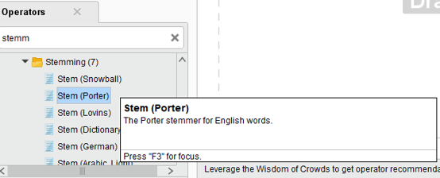

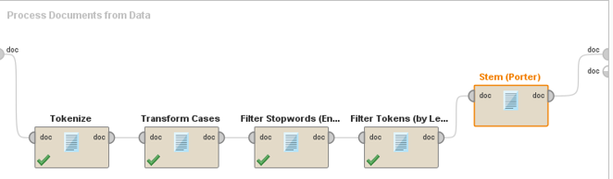

**And execute again n go in visualization**

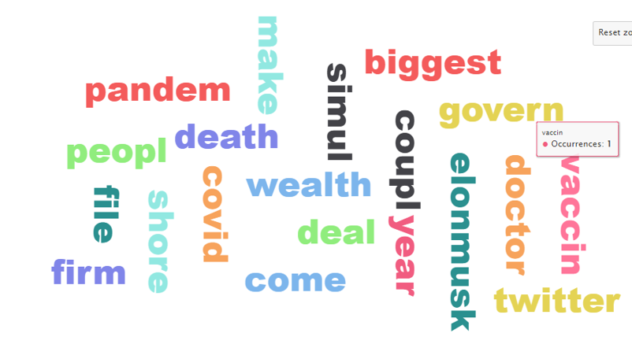

**For sentiment analysis:**

**Install operator tool box**

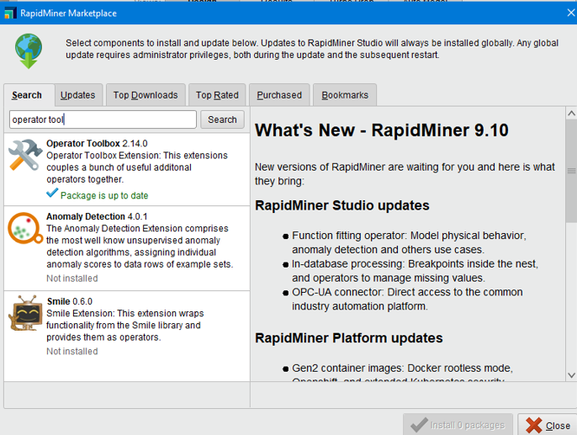

**Searvh EXTRACT SENTIMENTS**

**DRAG N DROP**

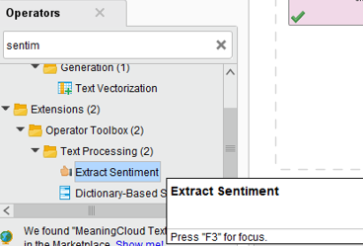

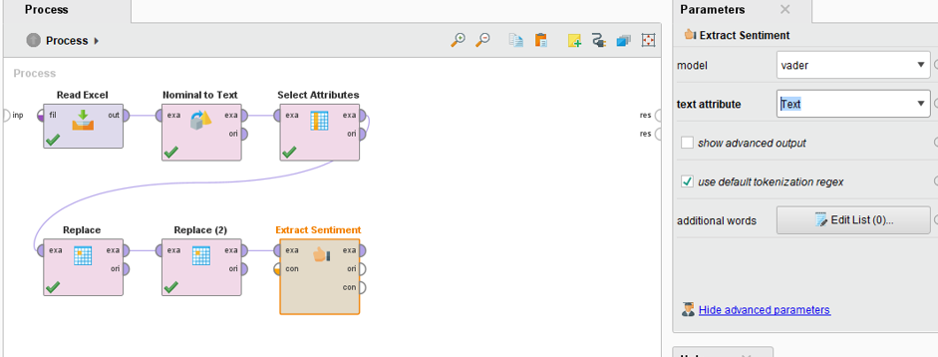 **And execute**

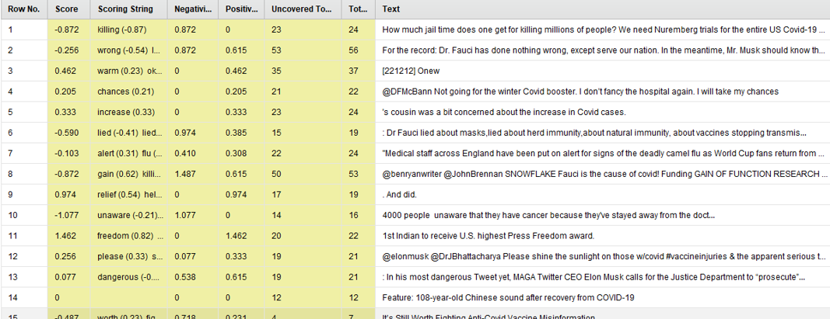

**select generate attribute from operator**

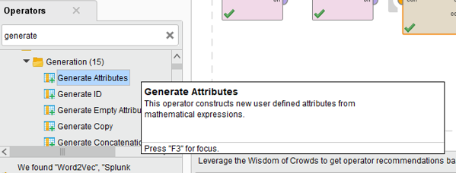

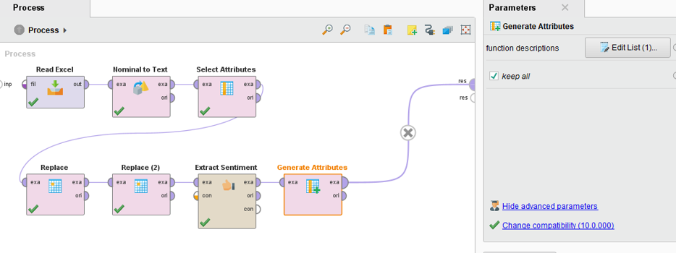

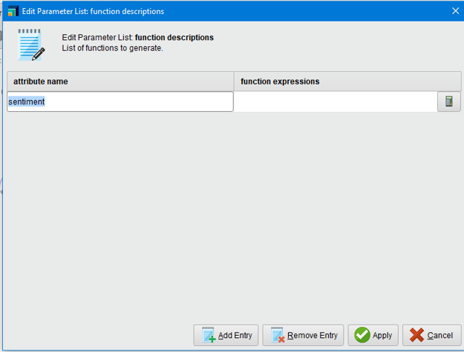

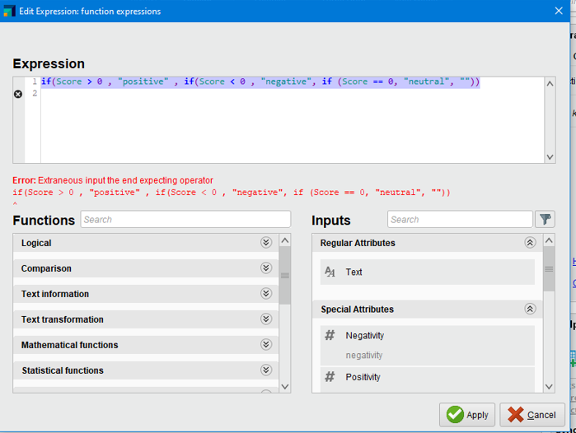

**And execute:**

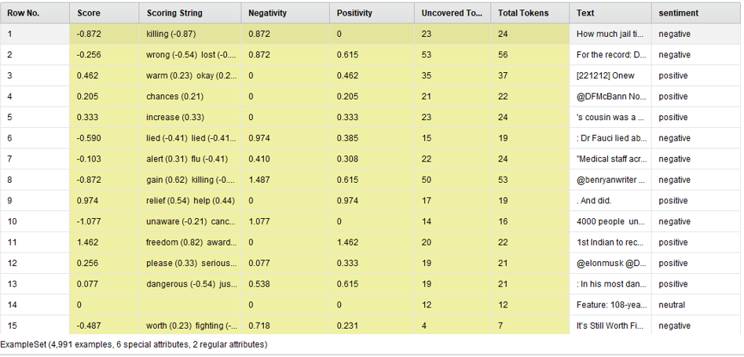 **Drag and drop write excel;**

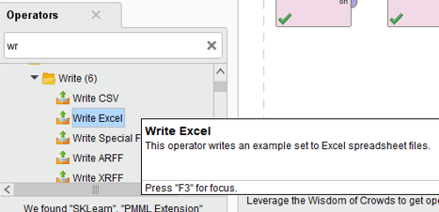

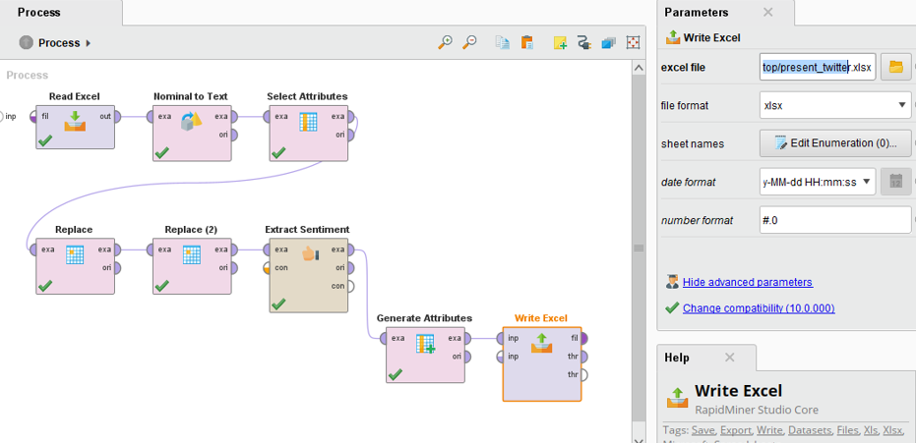

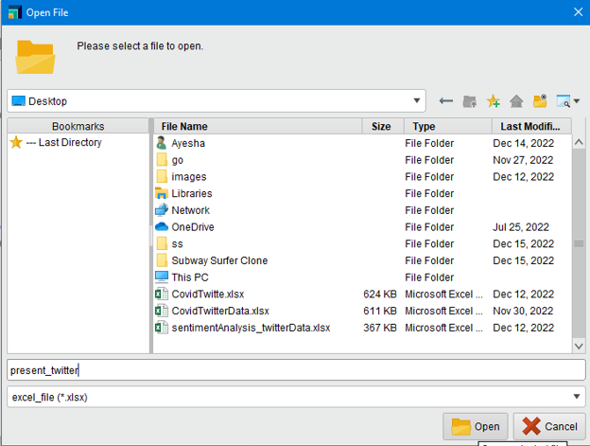

**Execute n file will be in destop**

